Сравнение дат зеркала в Ядре и Хадупе.

select * from DWS009_SV.V_CURR_TRANS009_MIRROR

where TRANS_DATE = to_date('20180425','yyyymmdd')

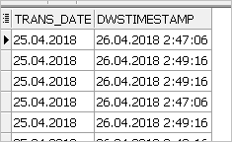

**в хадупе:**

SELECT

trans_date,

from_unixtime(cast(round(trans_date/1000) as bigint), 'yyyy-MM-dd HH:mm:ss') as trans_date2,

dwstimestamp,

from_unixtime(cast(round(dwstimestamp/1000) as bigint), 'yyyy-MM-dd HH:mm:ss') as dwstimestamp2

FROM s_odh.sv_v_curr_trans009_mirror

WHERE date_part='20180425'

limit 1;

